**025-US-SP-SOUTHAVEN**

025 Org

|  |  |
| --- | --- |
| 32160 | GALENA EQUIPMENT RENTAL LLC |

Order Number: 1010048254

Delivery Number: 963876868

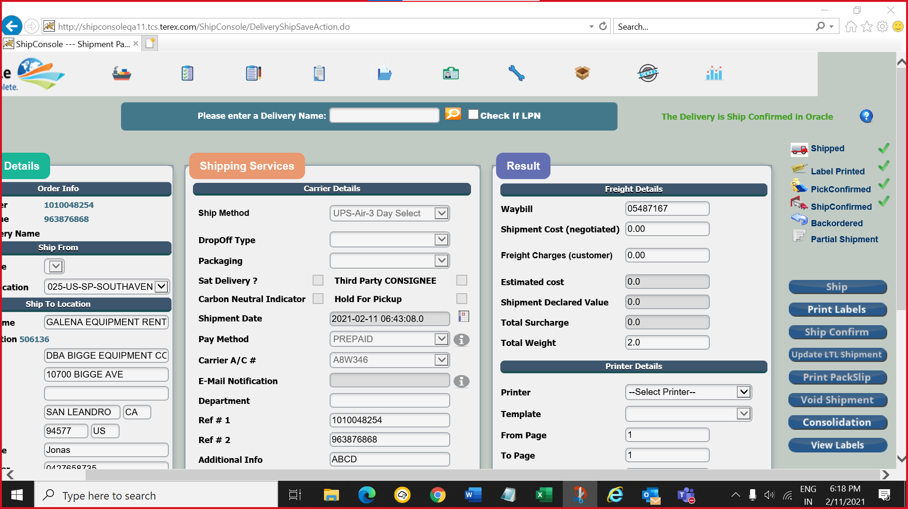

|  |  |
| --- | --- |
| 32020 | CROPAC EQUIPMENT INC. |

Order Number: 1010048260

Delivery Number: 963876869

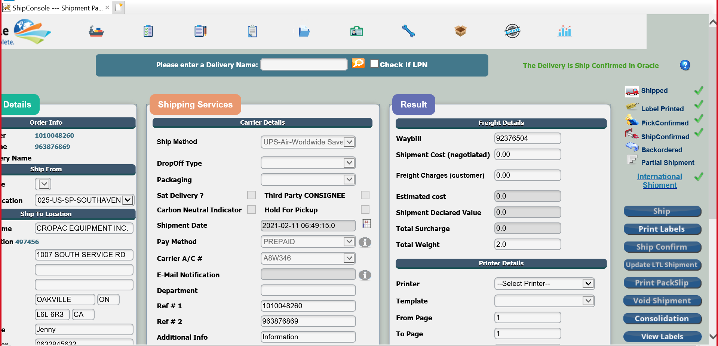

|  |  |
| --- | --- |
| 32160 | GALENA EQUIPMENT RENTAL LLC |

Order Number: 1010048261

Delivery Number: 963876870

